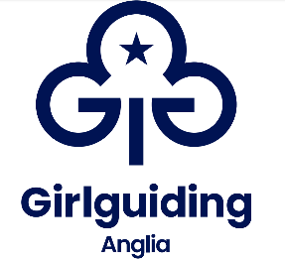
Girlguiding Anglia peer educator application form

Training dates: 16-18 February 2024
Training venue: Iceni House, Eaton Vale Scout and Guide centre, Church Lane, Norwich, NR4 6NN
Training topic: Think Resilient - gives girls the tools to build their mental well-being. Developed with YoungMinds
Attending the training is free of charge. Travel expenses will be reimbursed by your county.

Name: | Membership no:
DoB: | Age at training:
Current role in guiding: | County:
Email address:
Contact phone number:

If under 18:
Parent/carer full name:

Parent/carer email address:

Parent/carer contact number:

Please tick: ( ) I confirm that I have permission from my parent/carer to apply for this role.

Reference from a Girlguiding leader or commissioner who works with you regularly
Name of referee:

Role in guiding:

Membership number:

How long have they known you?

Please insert reference here (maximum 500 words)

Please answer the following three questions to help us determine whether becoming a peer educator is the right opportunity for you in guiding at this point in time.

Why do you want to be a peer educator? (maximum 200 words)

Tell us about a time you have demonstrated leadership skills. (maximum 200 words)

Peer educators train on a variety of topics. If you could choose, what would the next peer education topic be? (maximum 200 words)

Delete as appropriate:

I am/am not available for the peer education basic and topic training to be held in Norfolk 16-18 February 2024.
If I am not initially selected for the February 2024 training, I would/would not like to be put on the waiting list for the October 2024 training, if a space becomes available.
If I am not selected for the February 2024 training, I would/would not like to be put on the waiting list for any training run in 2025 (likely one in spring and one in autumn).

Signature of applicant:

Date:

Please send this form to your county peer education coordinator or to angliapeered@girlguiding-anglia.org.uk by Sunday 10 December 2023.

You will receive email notification when we receive your application, and an update on its status by Friday 15 December 2023 at the latest.

Further information can be found about Peer Education online here https://www.girlguiding.org.uk/information-for-volunteers/programme-and-activities/peer-education/

