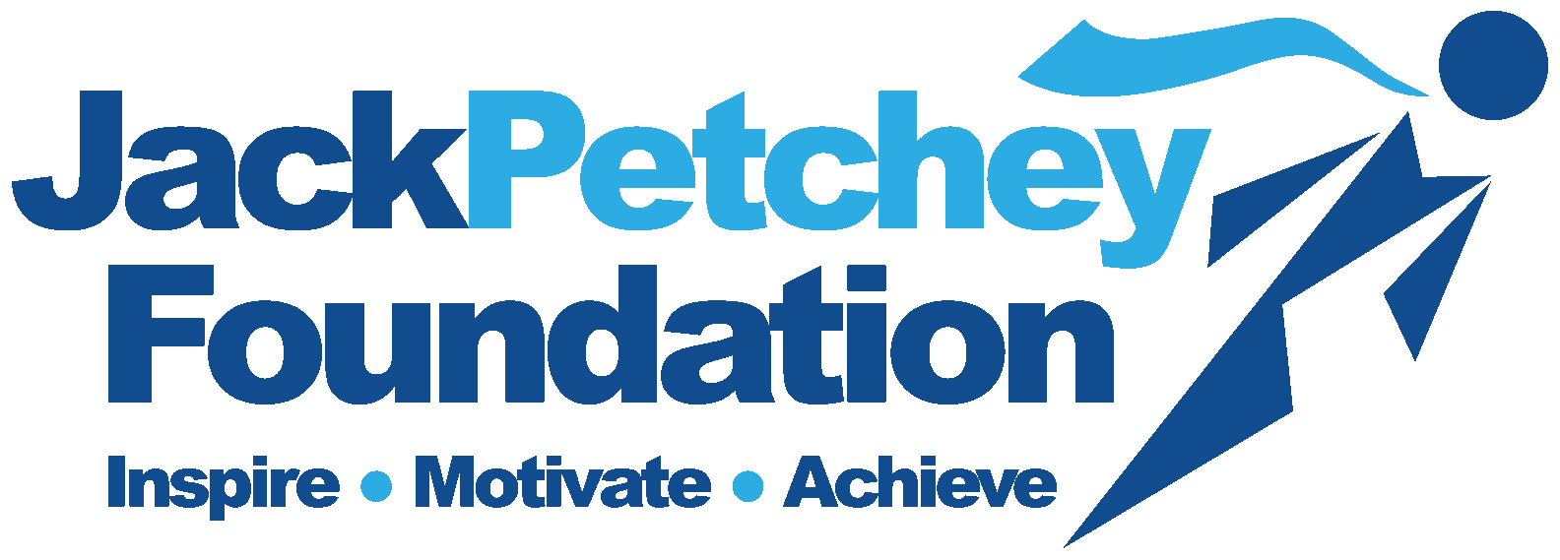

ACHIEVEMENT AWARD WINNER

CLUBS AND YOUTH ORGANISATIONS

Girlguiding Essex North East is entitled to elect Jack Petchey Achievement Award Winners. Recipients do not have to be the best at sport, work or anything else, but they must have contributed to Girlguiding or the community in a significant way. Equally, Achievement Award Winners can be recognised for personal developments and positive personality traits. Achievement Award Winners must be aged between 11 and 25 years.

Achievement Award Winners will receive:

- A framed certificate
- A pin badge
- A boxed medallion
- £300 to be a spent on a Girlguiding/community project of their choice

Please complete this form to make your nomination which MUST be without the knowledge of the nominee or her family

I nominate _______________________________________ Age ____of __________________________________Unit

Reason for nomination

Please continue overleaf if necessary

If successful, our nominee intends to spend the money on_____________________________________________________
This must be for the benefit of the whole Unit/community

Signed ……………………………………………………………………….. Name ………………………………………………..Date …………………………………..
Unit Member (nominator)

Supported by Guider …………………………….…………………… Name ………………………………………………..Date…………………………………….

Guider’s address …………………………………………………………………………………………………………………………………………………………………….

Guider’s phone no. …………………………………………………… Unit email address……………………………………………………………………………
or that of unit GO contact

Unit Bank Details Sort Code…………………………………… Account Number ……………………………………………………………………………….

If this application is successful the monies will be credited, using the BACS system, direct to your bank account

This form to be sent via email to office@girlguidingessexne.org.uk
or post to Girlguiding Essex NE County Office, Unit 7, Park Farm, Kelvedon Road, Inworth CO5 9SH

