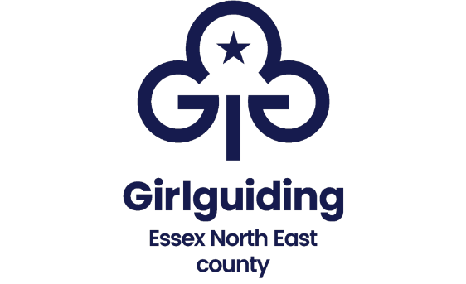
Wyvernwood Takeover Day
Sunday 9th June 2024

Thank you to everyone who registered interest in the county takeover of Wyvernwood on Sunday 9 June. Units can still apply even if their interest wasn’t registered. We are now able to offer this very exciting takeover day for units with girls aged 12 and under.
Bookings are now open but please note that, for safety, units will be allocated staggered timings for arrival and departure, between 8.45 and 10.45 and finishing between 3.00 and 5.00.
We have written an editable information and consent form that unit leaders may find helpful.

Units/districts will need to maintain the child adult (18+) ratio applicable to your section.
To book your spaces please complete the attached booking form and pay by one of the 2 options below:

Cheque payments. Return your form to Wyvernwood, County Office, Unit 7 Park Farm, Kelvedon Road, Inworth, Colchester, CO5 9SH together with a cheque made payable to Girlguiding Essex North East.
Online bank transfer. Pay by BACS (mark reference ‘Wyvernwood’)
Bank details- Sort code 40-19-43, Account number – 61084976 and
e-mail the form to ccevent@girlguidingessexne.org.uk after making your payment.

The closing date for bookings is Monday 22nd April 2024, for organisational and safety reasons we will be unable to extend the deadline or provide refunds.

All bookings will be acknowledged by Monday 29th April 2024 when you will be given your arrival and departure time. You will receive with a brief outline of the format for the day and details of anything you will need to bring with you.

What will it cost:
- £12 per girl and £5 per leader which includes entry, badge and activities (packed lunches will needed by everyone although refreshments are available to purchase on site)

This promises to be an exciting adventure for your girls, an opportunity to be a part of the wider guiding family, networking and sharing in the fun together.

Thank you for your support, The County Events Team
Please note that this is a large scale uniformed event.

Booking form
Wyvernwood takeover Sunday 9 June 2024

Unit name:

District:

Division:

Main unit contact name and number:

Main contact email address:

No of Rainbows:

No of Brownies:

No of Guides (12 and under):

Total number of leader places required (18+) to maintain the adult child ratio

No of YL’s:

Total Payment
£12 per girl
£5 per adult or young leader
Payment Method: (Please indicate whether BACs payment has been made or cheque is enclosed)
Any special requirements we should be aware of:
Please give some indication of your proposed method of transport ie. Coach or parents cars to help with arrival and departure arrangement

